**9**

**Linear Momentum and Collisions**

|  |
| --- |
| **CHAPTER OUTLINE** |

9.1 Linear Momentum

9.2 Analysis Model: Isolated System (Momentum)

9.3 Analysis Model: Nonisolated System (Momentum)

9.4 Collisions in One Dimension

9.5 Collisions in Two Dimensions

9.6 The Center of Mass

9.7 Systems of Many Particles

9.8 Deformable Systems

9.9 Rocket Propulsion

\* An asterisk indicates a question or problem new to this edition.

|  |
| --- |
| **SOLUTIONS TO THINK-PAIR-SHARE AND ACTIVITIES** |

**\*TP9.1 Conceptualize** Imagine the situation occurring: The ball rises in a parabolic trajectory. Just as it reaches its highest point, a horizontally flying eagle collides with it and reverses the direction of the velocity of the ball. The diagram below helps us to understand the situation.

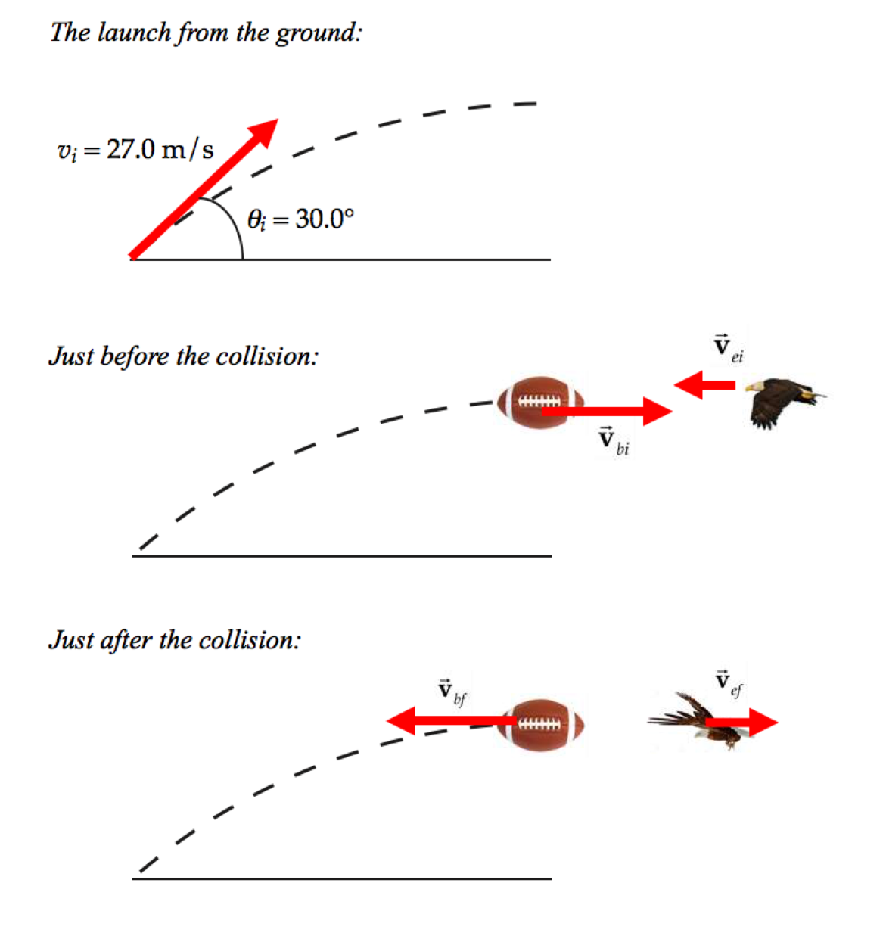

**Categorize** This is a collision problem, so we use the *isolated system* model for *momentum*. We also see that we categorize the collision as elastic. One of the objects in the collision is a kicked football, so we also categorize the problem as one involving a projectile.

**Analyze** The point in the trajectory at which the ball rebounded from the eagle is the highest point. Therefore, the football is traveling horizontally at that instant. According to the problem statement, the ball also travels horizontally just after the collision. Therefore, the time interval required to fall back to the ground is the same as that for it to rise to its highest point. Furthermore, because the ball lands back at the point from which it was kicked, it travels the same horizontal distance as it did when rising. With the same horizontal distance and the same time interval, we see that the velocity vector of the ball must be simply reversed during the collision, but will maintain the same magnitude.

(a) We begin by writing Equations 9.16 and 9.20:

 (1)

 (2)

where the ball is represented by mass *mb*, initial velocity *vbi*, and final velocity *vbf*, and the eagle by *me*, *vei*, and *vef*. Multiply Equation (2) by *me*:

 (3)

Subtract Equation (3) from Equation (1) to eliminate the final velocity of the eagle:

 (4)

The velocity component *vbi* of the ball just before the collision is the *x* component of the velocity of the ball after it is kicked, so *vbi* = *vi*cos*i*, where *vi* is the initial velocity magnitude of the kicked ball and *i* is the launch angle. We have also argued that the velocity of the ball just after the collision has the same magnitude but opposite direction. Therefore, *vbf* = –*vi*cos*i*. Making these substitutions into Equation (4) gives

 (5)

Substituting numerical values gives



(b) As the collision occurs, the eagle is too startled to begin flapping his wings to recover, so we can continue to ignore air resistance for a moment. Solve Equation (2) for the final velocity of the eagle:



(c) In the case of the inelastic collision, some kinetic energy will be transformed to other forms of energy. Therefore, to provide the necessary velocity of the ball to return to the point from which it was kicked, the eagle must fly faster than what we found in part (a).

**Finalize** Notice that the eagle’s velocity is simply reversed, with the same

magnitude, just as for the ball. This conclusion follows immediately from the

conservation of kinetic energy in an elastic collision: because the ball's velocity

simply reverses after the collision, its speed remains the same, and therefore its

kinetic energy remains the same. Because the total kinetic energy is conserved in

an elastic collision, it follows that the eagle's speed cannot change either, and this

implies that the eagle's velocity simply reverses as well.

*Answers:* (a) –2.24 m/s (b) +2.24 m/s (c) higher

**\*TP9.2 Conceptualize** If the cardboard triangle is to hang with its long leg parallel to the table, the string must be attached at a point directly above the center of gravity of the triangle, which is the same as its center of mass because it is in a uniform gravitational field.

**Categorize** As in the case of Example 9.11, we categorize this example as an analysis problem because it is necessary to identify infinitesimal mass elements of the triangle to perform the integration in Equation 9.32.

**Analyze** We assume the cardboard triangle has a total mass *M*. Because the triangle is a continuous distribution of mass, we must use the integral expression in Equation 9.32 to find the *x* coordinate of the center of mass.

We divide the triangle with legs *a* and *b* into narrow strips of width *dx* and height *y* as shown in Figure ANS P9.2, where *y* is the height of the hypotenuse of the triangle above the *x* axis for a given value of *x*. The mass of each strip is the product of the volume of the strip and the density ** of the cardboard from which the triangle is made: *dm* = *yt dx*, where *t* is the thickness of the triangle. The density of the material is the total mass of the triangle divided by its total volume (area of the triangle times thickness).

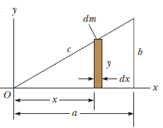

**ANS FIG P9.2**

Evaluate *dm*:

 (1)

Use Equation 9.32 to find the *x* coordinate of the center of mass:

 (2)

To proceed further and evaluate the integral, we must express *y* in terms of *x*. The line representing the hypotenuse of the triangle in Figure ANS P9.2 has a slope of *b*/*a* and passes through the origin, so the equation of this line is *y* = (*b*/*a*)*x*. Substitute for *y* in Equation (2):



Therefore, the string must be attached to the triangle at a distance two-thirds of the length of the bottom edge from the left end.

|  |
| --- |
| **SOLUTIONS TO END-OF-CHAPTER PROBLEMS** |

Section 9.1 Linear Momentum

P9.1 (a) The momentum is p = mv, so *v* = *p*/*m* and the kinetic energy is



(b)  implies  so 

**P9.2** We are given *m* = 3.00 kg and 

(a) The vector momentum is then



Thus,  and .

(b) 

at an angle of



**P9.3** We apply the impulse-momentum theorem to find the average force the bat exerts on the baseball:



Choosing the direction toward home plate as the positive x direction, we have 





By Newton’s third law,

 so 

Section 9.2 Analysis Model: Isolated System (Momentum)

**P9.4** (a) Brother and sister exert equal-magnitude oppositely-directed forces on each other for the same time interval; therefore, the impulses acting on them are equal and opposite. Taking east as the positive direction, we have

impulse on boy: 

impulse on girl: 

Her speed is then



meaning 

(b) original chemical potential energy in girl’s body = total final kinetic energy



(c)  System momentum is conserved with the value zero.

(d) The forces on the two siblings are internal forces, which cannot change the momentum of the system—

(e) 

P9.5 (a) For the system of two blocks  or . Therefore,



Solving gives  (motion toward the left).

(b) 

(c) 

(d) A force had to be exerted over a displacement to compress the spring, transferring energy into it by work. 

(e) 

(f) The forces on the two blocks are internal forces, which cannot change the momentum of the system— 

(g) 

P9.6 I have mass 72.0 kg and can jump to raise my center of gravity 25.0 cm. I leave the ground with speed given by



*vi* = 2.20 m/s

Total momentum of the system of the Earth and me is conserved as I push the planet down and myself up:



**Section 9.3 Analysis Model: Nonisolated System (Momentum)**

P9.7 (a) The mechanical energy of the isolated spring-mass system is conserved:



(b) 

(c) For the glider, 

The mass makes  to the work.

P9.8 **Conceptualize** Imagine the crash occurring. While the seat belt brings the wife to a rapid stop, the only thing bringing the child to a stop is the force from the mother’s arms. In your experience driving, you know that you are “thrown forward” relative to the car when it brakes hard. The acceleration in a violent crash has a much larger magnitude, so a very strong force is necessary to keep an occupant from sliding forward relative to the car during the crash.

**Categorize** We model the toddler as a *nonisolated system* for *momentum*.

**Analyze** Write Equation 9.13 for the toddler:

 (1)

where the *x* direction is along the direction of velocity of the car in which the toddler is driving. Now use Equations 9.2 and 9.11 to substitute for both sides of Equation (1):

 (2)

where *m* is the mass of the toddler, ∆*t* is the time interval during which the toddler is brought to rest, and *Fx*,avg is the force that your brother’s wife must apply with her arms to bring the toddler to rest along with her. Solve Equation (2) for this force:



Substitute numerical values:



where the minus sign indicates that your brother’s wife must apply a force toward herself to keep the child from moving forward relative to her. The magnitude of this force is 3.2 × 103 N.

**Finalize** This is a tremendous amount of force, equivalent to over 700 pounds.

Ask your brother if you think his wife could lift a 700-pound barbell with her

arms.

*Answer:* 3.2 × 103 N

**P9.9** (a) From the kinematic equations,

****

(b) We find the average force from the momentum-impulse theorem:



(c) Using the particle under constant acceleration model,

****

P9.10 (a) The impulse is in the *x* direction and equal to the area under the F-t graph:





(b) From the momentum-impulse theorem,



(c) From the same equation,



(d) 

P9.11 After 3.00 s of pouring, the bucket contains

(3.00 s)(0.250 L/s) = 0.750 liter

of water, with mass (0.750 L)(1 kg/1 L) = 0.750 kg, and feeling gravitational force (0.750 kg)(9.80 m/s2) = 7.35 N. The scale through the bucket must exert 7.35 N upward on this stationary water to support its weight. The scale must exert another 7.35 N to support the 0.750-kg bucket itself.

Water is entering the bucket with speed given by





The scale exerts an extra upward force to stop the downward motion of this additional water, as described by



The rate of change of momentum is the force itself:



which gives



Altogether the scale must exert 7.35 N + 7.35 N + 1.78 N = 

**Section 9.4 Collisions in One Dimension**

P9.12 (a) Conservation of momentum gives



Solving for the final velocity of the truck gives 

(b) We compute the change in mechanical energy of the car-truck system from



Note: If 20.9 m/s were used to determine the energy lost instead of 20.9333 as the answer to part (a), the answer would be very different. We have kept extra digits in all intermediate answers until the problem is complete.

(c) The mechanical energy of the car-truck system has decreased. Most of the energy was transformed to internal energy with some being carried away by sound.

**P9.13** (a) We write the law of conservation of momentum as



or 

(b) 

**:Art:Chapter 08 art:P08_14.epsP9.14** (a) The internal forces exerted by the actor do not change the total momentum of the system of the four cars and the movie actor. Conservation of momentum gives

**ANS. FIG. P9.14**



(b) 



(c) 

P9.15 The collision is completely inelastic.

(a) Momentum is conserved by the collision:



(b) We compute the change in mechanical energy of the car-truck system from



**P9.16** Let’s first analyze the situation in which the wood block, of mass   
*m*w = 1.00 kg, is held in a vise. The bullet of mass *m*b = 7.00 g is initially moving with speed *v*b and then comes to rest in the block due to the kinetic friction force *f*k between the block and the bullet as the bullet deforms the wood fibers and moves them out of the way. The result is an increase in internal energy in the wood and the bullet. Identify the wood and the bullet as an isolated system for energy during the collision:



Substituting for the energies:

 **[1]**

where *d* = 8.00 cm is the depth of penetration of the bullet in the wood.

Now consider the second situation, where the block is sitting on a frictionless surface and the bullet is fired into it. Identify the wood and the bullet as an isolated system for energy during the collision:



Substituting for the energies:

 **[2]**

where *vf* is the speed with which the block and imbedded bullet slide across the table after the collision and *d’* is the depth of penetration of the bullet in this situation. Identify the wood and the bullet as an isolated system for momentum during the collision:

 **[3]**

Solving equation [3] for *v*b, we obtain

 **[4]**

Solving equation [1] for *f*k*d* and substituting for *v*b from equation [4] above:

 **[5]**

Solving equation [2] for *f*k*d’* and substituting for *v*b from equation [4]:

 [6]

Dividing equation [6] by [5] gives



Solving for *d’* and substituting numerical values gives



P9.17 (a) The speed *v* of both balls just before the basketball reaches the ground may be found from  as



(b) Immediately after the basketball rebounds from the floor, it and the tennis ball meet in an elastic collision. The velocities of the two balls just before collision are

for the tennis ball (subscript *t*): 

and for the basketball (subscript *b*): 

We determine the velocity of the tennis ball immediately after this elastic collision as follows:

Momentum conservation gives



or  **[1]**

From the criteria for a perfectly elastic collision:



or  **[2]**

Substituting equation [2] into [1] gives



or the upward speed of the tennis ball immediately after the collision is



The vertical displacement of the tennis ball during its rebound following the collision is given by  as



Substituting,



P9.18 (a) Using conservation of momentum, , gives



Therefore, *v* = +2.24 m/s, or .

(b)  For example, if the 10.0-kg and 3.00-kg masses were to stick together first, they would move with a speed given by solving



or 

Then when this 13.0-kg combined mass collides with the 4.00-kg mass, we have



and *v* = +2.24 m/s, just as in part (a).



**Section 9.5 Collisions in Two Dimensions**

P9.19 **Conceptualize** See Figure 9.13 for an approximation of the collision. The numbers in this problem will differ from those in the figure.

**Categorize** The two cars are modeled as an *isolated system* for *momentum* in the horizontal plane. If we look at the instants just before the collision and just after, any friction between the cars and the roadway will be negligible because of the very short time interval, and we can use the impulse approximation.

**Analyze** Write a conservation of momentum equation for the system in the east–west direction:

 (1)

where we have recognized that both cars have the same mass and have used subscripts N and E to indicate the northbound (defendant’s) car and the eastbound (plaintiff’s) car, respectively.

Similarly, for the north–south direction,

 (2)

Substitute for the various velocity components:

East–west:  (3)

North–south:  (4)

In these equations, we do know the angle **, but we do not know the final speed *Vf* of the combined wreckage. Divide Equation (4) by Equation (3) and solve for the initial speed of the defendant:



Substitute numerical values:



Convert the result to mi/h:



The data from the accident scene show that the defendant was exceeding the speed limit of 35 mi/h.

**Finalize** Notice that we were able to solve this problem even without knowing

the final speed of the combined wreckage. That’s good news, because that

quantity would have been virtually impossible to measure. We also did not have

to know anything about the length of the skid marks. Although this

measurement would have been easy to make, we don't need it!

*Answer:* The defendant was traveling at 41.5 mi/h.

P9.20 We write the conservation of momentum in the *x* direction,, as



 [1]

and the conservation of momentum in the *y* direction, **** as



 [2]

Solving equations [1] and [2] simultaneously gives,

 and 

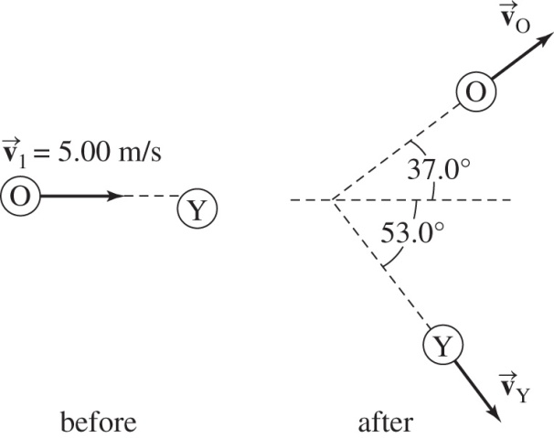

ANS. FIG. P9.20

P9.21 ANS. FIG. P9.20 illustrates the collision. We write the conservation of momentum in the *x* direction,, as

 **[1]**

and the conservation of momentum in the y direction, **** as

 **[2]**

From equation [2],

 **[3]**

Substituting into equation [1],



so



Then, from equation [3], .

We did not need to write down an equation expressing conservation of mechanical energy. In this situation, the requirement on perpendicular final velocities is equivalent to the condition of elasticity.

P9.22 (a) 

(b) First, we conserve momentum for the system of two football players in the x direction (the direction of travel of the fullback):

(90.0 kg)(5.00 m/s) + 0 = (185 kg)*V* cos*θ*

where *θ* is the angle between the direction of the final velocity V and the x axis. We find

*V* cos *θ* = 2.43 m/s **[1]**

Now consider conservation of momentum of the system in the y direction (the direction of travel of the opponent):

(95.0 kg)(3.00 m/s) + 0 = (185 kg)*V* sin *θ*

which gives

*V* sin*θ* = 1.54 m/s **[2]**

Divide equation [2] by [1]:



From which, 

Then, either [1] or [2] gives .

(c) 



Thus, the kinetic energy lost is 

**:Art:Chapter 08 art:P08_28.eps**P9.23 (a) The vector expression for conservation of momentum,   


 **[1]**

 [2]

From [2],  so 

ANS. FIG. P9.23

Furthermore, energy conservation for the system of two protons requires



so



(b) Hence, [1] gives



with  and 

**Section 9.6 The Center of Mass**

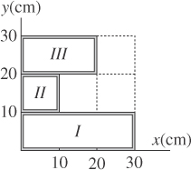P9.24 We could analyze the object as nine squares, each represented by an equal-mass particle at its center. But we will have less writing to do if we think of the sheet as composed of three sections, and consider the mass of each section to be at the geometric center of that section. Define the mass per unit area to be  and number the rectangles as shown. We can then calculate the mass and identify the center of mass of each section.

ANS. FIG. P9.24

*mI* = (30.0 cm)(10.0 cm)*σ* with *CMI* = (15.0 cm, 5.00 cm)

*mII* = (10.0 cm)(20.0 cm)*σ* with *CMII* = (5.00 cm, 20.0 cm)

*mIII* = (10.0 cm)(10.0 cm)*σ* with *CMIII* = (15.0 cm, 25.0 cm)

The overall center of mass is at a point defined by the vector equation:



Substituting the appropriate values,  is calculated to be:



Calculating,



and evaluating, 

**P9.25** The volume of the monument is that of a thick triangle of base   
L = 64.8 m, height H = 15.7 m, and width W = 3.60 m: V = ½ *LHW* = 1.83 × 103 m3. The monument has mass M = *ρ*V = (3 800 kg/m3)V =   
6.96 × 106 kg. The height of the center of mass (CM) is yCM = H/3 (derived below). The amount of work done on the blocks is



We derive yCM = H/3 here:

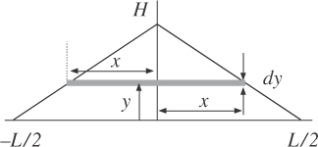 We model the monument with the figure shown above. Consider the monument to be composed of slabs of infinitesimal thickness dy stacked on top of each other. A slab at height y   
has a infinitesimal volume element   
dV = 2xWdy, where W is the width of the monument and x is a function of height y.

ANS. FIG. P9.25

The equation of the sloping side of the monument is



where x ranges from 0 to + L/2. Therefore,



where y ranges from 0 to H. The infinitesimal volume of a slab at height y is then



The mass contained in a volume element is dm = *ρ* dV.

Because of the symmetry of the monument, its CM lies above the origin of the coordinate axes at position yCM:



where we have used 

P9.26 This object can be made by wrapping tape around a light, stiff, uniform rod.

(a) 

(b) 

**Section 9.7 Systems of Many Particles**

**:Art:Chapter 08 art:P08_38.eps**P9.27 (a) ANS. FIG. P9.27 shows the position   
vectors and velocities of the particles.

(b) Using the definition of the position   
vector at the center of mass,



ANS. FIG. P9.27

(c) The velocity of the center of mass is



(d) The total linear momentum of the system can be calculated as  or as **** Either gives



P9.28 The vector position of the center of mass is (suppressing units)



(a) At *t* = 2.50 s,



(b) The velocity of the center of mass is obtained by differentiating the expression for the vector position of the center of mass with respect to time:



At *t* = 2.50 s,



Now, the total linear momentum is the total mass times the velocity of the center of mass.



(c) As was shown in part (b), 

(d)k Differentiating again, 

The center of mass acceleration is  at

t = 2.50 s and at all times.

(e) The net force on the system is equal to the total mass times the acceleration of the center of mass:



P9.29 **Conceptualize** Imagine the drone hovering at rest above the house. It explodes into four pieces, which fly off in different directions. Your task is to determine if the drone simply exploded, or if it were struck by a meteorite.

**Categorize** If the drone were struck by a meteorite, we have a collision process. But we don’t know whether or not this occurred, and, if it did, we have no information about the meteorite: its mass, speed, and direction of velocity are all unknown. The important piece of information in the problem is that the drone was *at rest*. Therefore, its center of mass had zero velocity and was located over the center of the house before the explosion/collision. If the drone simply exploded, the center of mass of the pieces must still be at the center of the house. If there were a collision, the center of mass of the drone would move during the collision and no longer be at the center of the house. Therefore, we categorize this problem as one involving the calculation of the center of mass of the four pieces.

**Analyze** From Equation 9.31, we calculate the center of mass of the four pieces of the drone, using the center of the house as the origin, the east–west direction as the *x* axis, and the north–south direction as the *y* axis:



If the drone were at rest and experienced an explosion, its center of mass would be at the center of the house both before and after the explosion. Because the final center of mass of the pieces is not at the center of the house, the evidence suggests that the drone was hit by a meteorite.

**Finalize** The final center of mass is roughly northwest of the house, suggesting

that that is the direction of travel of the meteorite that hit the drone.

*Answer:* The drone was struck by a meteorite.

**Section 9.8 Deformable Systems**

P9.30 (a)  The only horizontal force on the vehicle is the frictional force exerted by the floor, so it gives the vehicle all of its final momentum, 

(b) 

(c) 

(d) 

(e) 

P9.31 (a)  The floor exerts a force, larger than the person’s weight over time as he is taking off.

(b)  The work by the floor on the person is zero because the force exerted by the floor acts over zero distance.

(c) He leaves the floor with a speed given by , or



so his momentum immediately after he leaves the floor is



(d) 

(e) His kinetic energy is



(f) 

**Section 9.9 Rocket Propulsion**

**P9.32** The force exerted on the water by the hose is



According to Newton’s third law, the water exerts a force of equal magnitude back on the hose. Thus, the gardener must apply a 15.0-N force (in the direction of the velocity of the exiting water stream) to hold the hose stationary.

P9.33 In  we solve for Mi .

(a) 

The mass of fuel and oxidizer is



(b) 

(c) 

P9.34 (a) From the equation for rocket propulsion in the text,



Now,  so 

With the definition,  this becomes



(b) With, ve = 1 500 m/s, and Tp = 144 s,



|  |  |  |
| --- | --- | --- |
| *t* (s) | *v* (m/s) | P9 **ANS. FIG. P9.34(b)** |
| 0 | 0 |
| 20 | 224 |
| 40 | 488 |
| 60 | 808 |
| 80 | 1 220 |
| 100 | 1 780 |
| 120 | 2 690 |
| 132 | 3 730 |

(c) 

or 

(d) With, ve = 1 500 m/s, and Tp = 144 s, .

|  |  |  |
| --- | --- | --- |
| *t* (s) | *a* (m/s2) | P9  **ANS. FIG. P9.34(d)** |
| 0 | 10.4 |
| 20 | 12.1 |
| 40 | 14.4 |
| 60 | 17.9 |
| 80 | 23.4 |
| 100 | 34.1 |
| 120 | 62.5 |
| 132 | 125 |

(e) 



(f) With, ve = 1.500 m/s = 1.50 km/s, and Tp = 144 s,



|  |  |  |
| --- | --- | --- |
| *t* (s) | *x* (m) | **P9**  **ANS. FIG. P9.34(f)** |
| 0 | 0 |
| 20 | 2.19 |
| 40 | 9.23 |
| 60 | 22.1 |
| 80 | 42.2 |
| 100 | 71.7 |
| 120 | 115 |
| 132 | 153 |

**Additional Problems**

P9.35 (a) The system is isolated because the skater is on frictionless ice — if it were otherwise, she would be able to move. Initially, the horizontal momentum of the system is zero, and this quantity is conserved; so when she throws the gloves in one direction, she will move in the opposite direction because the total momentum will remain zero. The system has total mass M. After the skater throws the gloves, the mass of the gloves, m, is moving with velocity **** and the mass of the skater less the gloves, *M* – m, is moving with velocity ****



The term *M* – m is the total mass less the mass of the gloves.

(b) 

P9.36 (a) In the same symbols as in the text’s Example, the original kinetic energy is



The example shows that the kinetic energy immediately after latching together is



so the fraction of kinetic energy remaining as kinetic energy is



(b) Momentum is conserved in the collision so momentum after divided by momentum before is 

**P9.37** (a) Conservation of momentum for   
this totally inelastic collision   
gives

** **

**ANS. FIG. P9.37**





(b) To obtain the force of friction, we first consider Newton’s second law in the *y* direction,  which gives



or *n* = 588 N. The force of friction is then





(c) The change in the person’s momentum equals the impulse, or







(d) The change in momentum of the person is



The change in momentum of the cart is



(e) 

(f) 

(g) 

(h) 

(i) 

(c) 

**:Art:Chapter 08 art:P08_58.epsP9.38**  (a) Use conservation of the horizontal component of momentum for the system of the shell, the cannon, and the carriage, from just before to just after the cannon firing:



**ANS. FIG. P9.38**





or 

(b) Use conservation of energy for the system of the cannon, the carriage, and the spring from right after the cannon is fired to the instant when the cannon comes to rest.







(c) 



(d)  The spring exerts a force on the system during the firing. The force represents an impulse, so the momentum of the system is not conserved in the horizontal direction. Consider the vertical direction. There are two vertical forces on the system: the normal force from the ground and the gravitational force. During the firing, the normal force is larger than the gravitational force. Therefore, there is a net impulse on the system in the upward direction. The impulse accounts for the initial vertical momentum component of the projectile.

P9.39 (a) Momentum of the bullet-block system is conserved in the collision, so you can relate the speed of the block and bullet right after the collision to the initial speed of the bullet. Then, you can use conservation of mechanical energy for the bullet-block-Earth system to relate the speed after the collision to the maximum height.

(b) Momentum is conserved by the collision. Find the relation between the speed of the bullet vi just before impact and the speed of the bullet + block v just after impact:

****

For the bullet-block-Earth system, total energy is conserved. Find the relation between the speed of the bullet-block v and the height h the block climbs to:



Combining our results, we find



P9.40 (a) Momentum of the bullet-block system is conserved in the collision, so you can relate the speed of the block and bullet right after the collision to the initial speed of the bullet. Then, you can use conservation of mechanical energy for the bullet-block-Earth system to relate the speed after the collision to the maximum height.

(b) Momentum is conserved by the collision. Find the relation between the speed of the bullet vi just before impact and the speed of the bullet + block v just after impact:



For the bullet-block-Earth system, total energy is conserved. Find the relation between the speed of the bullet-block v and the height h the block climbs to:



Combining our results, we find .

P9.41 (a) When the spring is fully compressed, each cart moves with same velocity *v*. Apply conservation of momentum for the system of two gliders



(b) Only conservative forces act; therefore, ∆E = 0.



Substitute for v from (a) and solve for xm.



(c) m1v1 + m2v2 = m1v1f + m2v2f

Conservation of momentum:  **[1]**

Conservation of energy: 

which simplifies to: 

Factoring gives 

and with the use of the momentum equation (equation [1]),

this reduces to 

or  **[2]**

Substituting equation [2] into equation [1] and simplifying yields



Upon substitution of this expression for into equation [2], one finds



Observe that these results are the same as two equations given in the chapter text for the situation of a perfectly elastic collision in one dimension. Whatever the details of how the spring behaves, this collision ends up being just such a perfectly elastic collision in one dimension.

P9. 42 (a) 

(b) We substitute v1f = 8.00 m/s – v2f :







(c) You transform potential energy stored in your body into kinetic energy of the system:





**P9.43** (a) We can obtain the initial speed of the projectile by utilizing conservation of momentum:



Solving for *v*1*A* gives



(b) We begin with the kinematic equations in the *x* and *y* direction:



And simplify by plugging in *x*0 = *y*0 = 0, *vy*0 = 0, *vx*0= *v*1*A*, *ax* = 0, and *ay* = *g*:



Combining them gives



Substituting the numerical values from the problem statement gives



(c) 

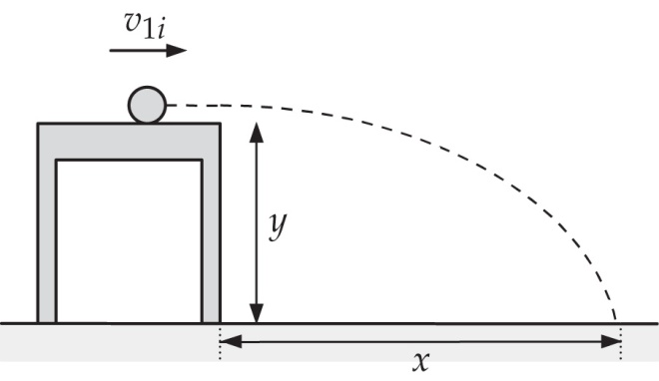

**ANS. FIG. P9.43**

P9.44 We hope the momentum of the equipment provides enough recoil so that the astronaut can reach the ship before he loses life support! But can he do it?

Relative to the spacecraft, the astronaut has a momentum   
p = (150 kg)(20 m/s) = 3 000 kg · m/s away from the spacecraft. He must throw enough equipment away so that his momentum is reduced to at least zero relative to the spacecraft, so the equipment must have momentum of at least 3 000 kg · m/s relative to the spacecraft. If he throws the equipment at 5.00 m/s relative to himself in a direction away from the spacecraft, the velocity of the equipment will be 25.0 m/s away from the spacecraft. How much mass travelling at 25.0 m/s is necessary to equate to a momentum of 3 000 kg · m/s?



which gives





**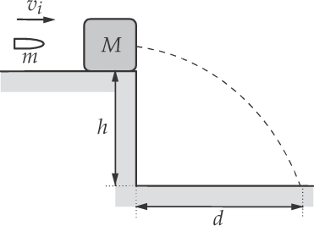**P9.45 Using conservation of momentum from just before to just after the impact of the bullet with the block:

mvi = (*M*+ m)vf

or  **[1]**

The speed of the block and embedded bullet just after impact may be found using kinematic equations:

**ANS. FIG. P9.45**

d = vf t and 

Thus,  and 

Substituting into [1] from above gives



P9.46 Refer to ANS. FIG. P9.45. Using conservation of momentum from just before to just after the impact of the bullet with the block:

mvi = (*M*+ m)vf

or  **[1]**

The speed of the block and embedded bullet just after impact may be found using kinematic equations:

d = vf t and 

Thus,  and 

Substituting into [1] from above gives 

**P9.47** (a) From conservation of momentum,







The original kinetic energy is



The final kinetic energy is



different from the original energy so the collision is 

(b) We follow the same steps as in part (a):





We see  so the collision is 

(c) Again, from conservation of momentum,





Then, from conservation of energy:



This gives, suppressing units, a quadratic equation in *a*,



which solves to give



With 



With 



P9.48 (a) Proceeding step by step, we find the stone’s speed just before collision, using energy conservation for the stone-Earth system:



which gives



Now for the elastic collision with the stationary cannonball, we use the specialized Equation 9.22 from the chapter text, with   
m1 = 80.0 kg and m2 = m:



The time for the cannonball’s fall into the ocean is given by



so its horizontal range is



(b) The maximum value for *R* occurs for  and is



(c) As indicated in part (b), the maximum range corresponds to 

(d) 

(e) The range is equal to the product of vcannonball, the speed of the cannonball after the collision, and t, the time at which the cannonball reaches the ocean. But vcannonball is proportional to vi, the speed of the stone just before striking the cannonball, which is, in turn, proportional to the square root of g. The time t at which the cannonball strikes the ocean is inversely proportional to the square root of g. Therefore, the product R = (vcannonball)t is independent of g. At a location with weaker gravity, the stone would be moving more slowly before the collision, but the cannonball would follow the same trajectory, moving more slowly over a longer time interval.

P9.49 The force exerted by the spring on each block is in magnitude.



(a) With no friction, the elastic energy in the spring becomes kinetic energy of the blocks, which have momenta of equal magnitude in opposite directions. The blocks move with constant speed after they leave the spring. From conservation of energy,





 [1]

And from conservation of linear momentum,





Substituting this into [1] gives



Solving,



(b) For the lighter block,





We assume that the maximum force of static friction is a similar size. Since 0.308 N is larger than 0.245 N, this block moves. For the heavier block, the normal force and the frictional force are twice as large: fk = 0.490 N. Since 0.308 N is less than this, the heavier block stands still. In this case, the frictional forces exerted by the floor change the momentum of the two-block system. The lighter block will gain speed as long as the spring force is larger than the friction force: that is until the spring compression becomes xf given by

 0.245 N = (3.85 N.m)xf , 0.063 6 m = xf

Now for the energy of the lighter block as it moves to this maximum-speed point, we have







Thus for the heavier block the maximum velocity is  and for the lighter block, 

(c) For the lighter block, fk = 0.462(2.45 N) = 1.13 N. The force of static friction must be at least as large. The 0.308-N spring force is too small to produce motion of either block. Each has  maximum speed.

**P9.50** The orbital speed of the Earth is



In six months the Earth reverses its direction, to undergo momentum change



Relative to the center of mass, the Sun always has momentum of the same magnitude in the opposite direction. Its 6-month momentum change is the same size, 

Then 

**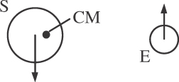**

**ANS. FIG. P9.50**

**P9.51** (a) We have, from the impulse-momentum theorem, 





(b) The particle’s acceleration is



(c) From Newton’s second law,



(d) The vector displacement of the particle is



(e) Now, from the work-kinetic energy theorem, the work done on the particle is



(f) The final kinetic energy of the particle is





(g) The final kinetic energy of the particle is



(h) 

**Challenge Problems**

 P9.52 A picture one second later differs by showing five extra kilograms of sand moving on the belt.

(a) 

(b) The only horizontal force on the sand is belt friction, which causes the momentum of the sand to change:  as above.

(c) The belt is in equilibrium:



(d) 

(e) 

(f) 

P9.53 The x component of momentum for the system of the two objects is

p1ix + p2ix = p1fx + p2fx

–mvi + 3mvi = 0 + 3mv2x

The y component of momentum of the system is

0 + 0 = –mv1y + 3mv2y

By conservation of energy of the system, 

we have 

also v1y = 3v2y

So the energy equation becomes





or 

(a) The object of mass m has final speed



and the object of mass 3m moves at





(b) 



P9.54 Depending on the length of the cord and the time interval ∆t for which the force is applied, the sphere may have moved very little when the force is removed, or we may have x1 and x2 nearly equal, or the sphere may have swung back, or it may have swung back and forth several times. Our solution applies equally to all of these cases.

(a) The applied force is constant, so the center of mass of the glider-sphere system moves with constant acceleration. It starts, we define, from x = 0 and moves to (x1 + x2)/2. Let v1 and v2 represent the horizontal components of velocity of glider and sphere at the moment the force stops. Then the velocity of the center of mass is vCM = (v1 + v2)/2, and because the acceleration is constant we have



which gives



The impulse-momentum theorem for the glider-sphere system is



or



Dividing both sides by 4m and rearranging gives



or



(b) The applied force does work that becomes, after the force is removed, kinetic energy of the constant-velocity center-of-mass motion plus kinetic energy of the vibration of the glider and sphere relative to their center of mass. The applied force acts only on the glider, so the work-energy theorem for the pushing process is



Substitution gives



Then,



When the cord makes its largest angle with the vertical, the vibrational motion is turning around. No kinetic energy is associated with the vibration at this moment, but only gravitational energy:



Solving gives



|  |
| --- |
| **ANSWERS TO QUICK-QUIZZES** |

1. (d)

2. (b), (c), (a)

3. (i) (c), (e) (ii) (b), (d)

4. (a) All three are the same. (b) dashboard, seat belt, air bag

5. (a)

6. (b)

7. (b)

8. (i) (a) (ii) (b)

|  |
| --- |
| **ANSWERS TO EVEN-NUMBERED PROBLEMS** |

P9.2 (a) (b) 15.0 kg . m/s

P9.4 (a) 4.71 m/s East; (b) 717 J

P9.6 10−23 m/s

P9.8 (a) 3.22 × 103 N, 720 lb; (b) not valid; (c) These devices are essential for the safety of small children.

P9.10 (a) 12.0 i cap N . s (b) 4.80 I cap m/s (c) 2.80 I cap m/s (d) 2.40 i capN

P9.12 (a) 20.9 m/s East; (b) −8.68 × 103 J; (c) Most of the energy was transformed to internal energy with some being carried away by sound.

P9.14 (a) 2.50 m/s; (b) 37.5 kJ; (c) The event considered in this problem is the time reversal of the perfectly inelastic collision in Problem 9.15. The same momentum conservation equation describes both processes.

P9.16 7.94 cm

P9.18 (a) 2.24 m/s toward the right; (b) No. Coupling order makes no difference to the final velocity.

P9.20 

P9.22 The opponent grabs the fullback and does not let go, so the two players move together at the end of their interaction; (b) *θ* = 32.3°, 2.88 m/s; (c) 786 J into internal energy

P9.24 11.7 cm; 13.3 cm

P9.26 (a) 15.9 g (b) 0.153 m

P9.28 (a) ; (b) ;

(c) ; (d) ;

(e) 

P9.30 (a) Yes.  (b) No. The friction force exerted by the floor on each stationary bit of caterpillar tread acts over no distance, so it does zero work; (c) Yes, we could say that the final momentum of the card came from the floor or from the Earth through the floor; (d) No. The kinetic energy came from the original gravitational potential energy of the Earth-elevated load system, in the amount 27.0 J; (e) Yes. The acceleration is caused by the static friction force exerted by the floor that prevents the wheels from slipping backward.

P9.32 15.0 N in the direction of the initial velocity of the exiting water stream.

P9.34 (a) ; (b) See ANS. FIG. P9.34(b); (c) ; (d) See ANS. FIG. P9.34(d); (e) ; (f) See ANS. FIG. P9.34(f)

P9.36 (a) ; (b) 1.00; (c) See P9.68(c) for argument.

P9.38 (a) –3.54 m/s; (b) 1.77 m; (c) 3.54 × 104 N; (d) No

P9.40 (a) See P9.40(a) for description; (b) 

P9.42 (a) See P9.42 for complete statement; (b) The final velocity of the seat is −0.055 6 m/s. That of the sleigh is 7.94 m/s; (c) −453 J

P9.44 In order for his motion to reverse under these conditions, the final mass of the astronaut and space suit is 30 kg, much less than is reasonable.

P9.46 

P9.48 (a) ; (b) 32.2 m; (c) *m* → 0; (d) See P9.48(d) for complete answer; (e) See P9.48(e) for complete answer.

P9.50 0.179 m/s

P9.52 (a) 3.75 N; (b) 3.75 N; (c) 3.75 N; (d) 2.81 J; (e) 1.41 J/s; (f) One-half of the work input becomes kinetic energy of the moving sand and the other half becomes additional internal energy. The internal energy appears when the sand does not elastically bounce under the hopper, but has friction eliminate its horizontal motion relative to the belt. By contrast, all of the impulse input becomes momentum of the moving sand.

P9.54 (a) *vCM=√*

(b)θ=cos-1